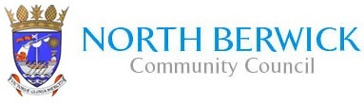

**Notice is hereby given that the Annual General Meeting of North Berwick Community Council will be held on Tuesday 5th November 2024 at 7.00 pm in the Community Centre, Law Road, North Berwick.**

**The Agenda will be**

1. **Welcome**
2. **Minutes of Meeting held on 7th November 2023**
3. **Financial Report**
4. **Chairman’s Report**
5. **Election of office bearers**

**Kathryn E Smith**

**Secretary**