Royal Burgh of North Berwick Community Council

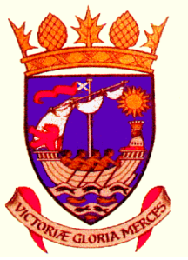
Chairman
Kenneth L Miller

Tel: 0758 400 0257
e-mail: kennymiller56@gmail.com

Secretary
(Miss) Kathryn E Smith

Tel: 01620 892341
e-mail: ksmith2028@aol.com

e-mail: ksmith2028@aol.com

Notice is hereby given that the Annual General Meeting of North Berwick Community Council will be held on Tuesday 7th November 2023 at 7.15 pm in the Community Centre, Law Road, North Berwick.

The Agenda will be

- Welcome
- Minutes of Meeting held on 1st November 2022
- Financial Report
- Chairman’s Report
- Election of office bearers

Kathryn E Smith
Secretary

