APPENDIX referred to in NBCC Response

Comments to North Berwick Community Council on the proposed amendment by Councillor Berry (seconded by Councillor Day) to the Draft East Lothian Local Development Plan (approved by ELC on 17 November2015) - the allocation of further sites for land for employment

Commentary is specifically in relation to the inclusion of Heugh Road West within the list of sites for consideration within the amendment.

This document is compiled and sent on behalf of the residents of Heugh Road, North Berwick.

Contact details: Mr Angus Bell & Mrs Tereasa Bell email: angus.bell@sky.com

Introduction

While we support the creation of employment opportunities and understand the need for zones of employment in North Berwick we were very surprised at the inclusion of Heugh Road West within the sites in the proposed amendment.

East Lothian Council appraised this site in 2014 and it was not included in the Main Issues Report or promoted as a preferred option in the Draft East Lothian Local Development plan; not least because of its importance as a landscape setting for North Berwick Law and its previous SSSI status. We believe that the reasons for excluding this site from consideration have become stronger rather than weaker and that Heugh Road West is entirely unsuitable for allocation of land for employment.

We would like to highlight that the Initial Site Assessment conducted by ELC does not include significant comments from the main consultation authorities including Scottish Natural Heritage, Historic Environment Scotland and Scottish Environmental Protection Agency which were included within the original Main Issues Report. We have referenced these in the attached Appendix 1 as they are particularly relevant to the Heugh Road West site.

Key points relating to theHeugh Road West site

- We feel that any development of this site should be aimed at improving and not undermining the North Berwick Law Special Landscape Area. With considerable new development to the east of Heugh Brae, already approved, East Lothian Council must take care not to change the town setting irrevocably. Scottish National Heritage and others have commented that development of this site risks changing the distinctive character of North Berwick.

- Alongside our coastline, North Berwick Law provides the scenic context for the town. The Law not only provides amenity for walkers and climbers, it is also home to a huge range of fauna and flora (including our well-loved Exmoor ponies). The Heugh Road West site borders this and allows for a biodiversity corridor for a myriad of species including (but not limited to): deer, swallows, oyster catchers, herons, pheasants, bats and the protected species pink footed geese and curlews (see Appendix 2).

- In recent winters the water run-off from the hillside has significantly affected the lower portion of the field with some flooding of adjacent residential gardens and causing a large section (over 40 foot) of a historic boundary wall to collapse (see Appendix 2). The field is directly adjacent to the Law marsh and the hydrology of the area needs reassessing to establish the potential effect of hard standing on the Glen Burn (and ultimately the beach).

- We are concerned that the Heugh Road West site is the only site that mentions odour and noise. If East Lothian Council are considering significant industrial development, this would be most inappropriate for reasons outlined above. A full environmental impact and health assessment should be undertaken before proceeding with further development.

- We question the wider long term employment strategy for the town. The old Ben Sayers site is currently being developed into residential housing as it was deemed to be no longer required for industrial use. We would comment that to now develop a Greenfield site adjacent to that land constitutes a lack of short-medium term planning strategy. We understand that the current planned industrial units have not yet attracted any interested parties. We would ask that a comprehensive audit is conducted to assess the types of employment opportunities that are required for North Berwick. For the purposes of the planned amendment, what is meant by ‘employment use’ and what category would be applied to each proposed site?

- Road traffic at the East end of the town would benefit from traffic calming measures as traffic entering the town from this direction is already very heavy and will be made heavier still by the McCarthy Stone development and the planned adjacent industrial units.

Key points relating to the full proposed amendment

- We would argue that the priority for employment development should be brownfield sites- vacant and derelict land and buildings should be considered first. We understand that there are currently a number of opportunities emerging where imaginative reuse of land that fits into the landscape would be more appropriate (e.g. North Berwick Police station; the Post Office sorting office; the bus depot; ELC property in Lime Grove and the (near) derelict hotel in the High Street).

- We would like to draw attention to inaccuracies to the proposed amendment document e.g. the Ferrygate East/Williamstone site and the Old Gas Works site are classed as ‘red’ against physical infrastructure capacity due to required access via Gasworks Lane. We would presume that the recently approved development to the West of the Ferrygate site (15/00966/AMM) will address the access issues affecting both sites.

- The Haddington Road East site raises many similar concerns to that outlined above in relation to Heugh Road West, including the potential to spoil the distinctive landscape

- If East Lothian Council feel it is essential to develop greenfield sites we would suggest that there are 3 other proposed sites where development would be less damaging to the biodiversity and landscape setting around North Berwick Law

  - Ferrygate East / Williamstone - it should be possible to negate the physical infrastructure issues by planned access as part of the new Ferrygate housing development. This site also scores green for Biodiversity, Flora & Fauna and Landscape.
  - Old Gas Works - it should be possible to negate the physical infrastructure issues by planned access as part of the new Ferrygate housing development. This site also has existing industrial development and no adjacent residential properties and scores green for landscape.
  - South Main Farm – the master plan for this site provided for employment development included within the residential development of 420 houses.

Conclusion

The proposed Heugh Road West site provides an important biodiversity corridor and is vital to the North Berwick Law Special Landscape Area.

Significant redevelopment and extension of the built up area is already underway to the east of Heugh Brae. We strongly suggest that any development should be contained to that side of the road as was recommended in the Main Issues Report.

Planned new development will include family homes and residences for the elderly, significantly increasing the population on the east side of the town. Safe community access to North Berwick Law is currently not possible from the east with the only access on foot available via Heugh Brae where there is no pavement.
We would suggest any development of Heugh Road West should be strictly limited to amenity development of community green space; improving pedestrian access to the Law for residents and visitors walking from the town or from the beach via the Glen footpath, with the potential to develop a circular route for the benefit of both local residents and visitors.

Appendix 1

Extract from the Initial Site Assessment conducted by ELC | Other relevant commentary from the consultation authorities within the Main Issues Report | Additional commentary from Heugh Road Residents
Biodiversity, Flora and Fauna – Score RED  It is situated next to North Berwick Law SSSI (Calcareous grassland) which is in an unfavourable and declining state (assessed 2007). In terms of notable species, curlew has been recorded within 100m of the site.  It is within a proposed Local Geodiversity Site, which seeks to protect local geological features | The land proposed to the west of Heugh Road/Heugh Brae is within the North Berwick Law SSSI (Calcareous grassland) which is in an unfavourable and declining state (assessed 2007). SNH has raised concerns with regards the site as proposed as development would intrude into this area.  SNH advises that the site provides suitable habitat for SPA species and there are  records of pink footed geese and golden plover in the tetrad. The site will therefore need to be screened into the Habitats Regulations Appraisal at this stage. Notable species have been recorded within100m of the site including herring gull, Eurasian curlew and fern grass | Several Eurasian curlews are regularly seen in the proposed area for development, especially in the North West section (protected species). Residents have photographic records to support this.  Herons are also regularly seen in this section, together with grouse and more recently deer.  Bats – common pipistelle and soprano pipistelle are evident in both the field and in the gardens of the residential properties. Bat survey conducted May 22nd 2016 by expert bat researchers.  (Schedule 2 European Protected Species Directive)  Previous ELC reports have mentioned pink footed geese also a protected species.  European Directive 79/409/EEC on the conservation of birds.  The site is adjacent to the wildlife corridor of the Law and disruption of this corridor would have a detrimental effect upon the integrated habitat network and maintenance of biodiversity. This is evidenced to date by the movement between the sites of Herons, magpies, frogs, pink- footed geese. There is likely to be more impact that we have not as yet captured.
Landscape –  Score RED  The site to the west of Heugh Brae lies within the proposed North Berwick Law Special Landscape Area (SLA), an area seen as integral to the setting of North Berwick Law. Any built development within this site could detract from the visual dominance and focal point of North Berwick Law. | SNH has raised concerns that development on the site would significantly change the character of this eastern part of the town, where development is presently largely contained to the north of the A198. | ELC appraised this site in 2014 and it was not included in the MIR or promoted as a preferred option because of its importance as a landscape setting for the Law and its SSSI status.  Scottish Government Planning Guidance suggests that development of sites of environmental, historic and cultural significance is enhanced by such development. All elements of the impact should be considered (point 112 and 37). In addition setting of such sites is considered as more than the immediate surroundings of a site. It is important to consider how it fits into the landscape/townscape. The view is seen as important to the protection of such sites (point 112).
Water  Score – Amber  Due to the steep slope of the southern part of the site and land to the south, consideration would need to be given to ensuring that surface water run off is dealt with without resulting in adverse impacts down slope. |  | During last winter a large section (over 40 feet) of the perimeter wall (which is over 5 feet in height) to the west of the proposed site collapsed during a period of heavy rain. We believe that this was due to the ground being saturated from run off from the steep slope to the south of the field and that a full assessment would need to be conducted of the increased risk to properties bordering the north of the proposed site. In addition, there was significant water collection to the north east corner of the proposed site last winter. Run off into the gardens has resulted in flooding (photographic evidence available).  Please note that the site is adjacent to an area of bullrush wetland which has increased in size in recent years. Assessment would be required on the effect of hard standing to prevent any unwanted discharge entering the Glen Burn and ultimately the beach.
Suitability for proposed use  Score – Amber  There could be potential conflicts with adjoining housing however this could be managed by conditions on planning permission. |  | We would like to draw attention to the significant impact to the residents of Heugh Road of two planning developments since the MIR was published.  Aldi Supermarket –the development and extension of the Aldi supermarket has caused a considerable increase in noise and light pollution. The woodland border that is supposed to give residents some protection was significantly reduced as the car park area was extended. A development of the proposed site would effectively surround a mature residential area with high impact commercial and industrial uses.  McCarthy and Stone development –it should be noted that a change of use was granted from industrial to residential to allow the development of the new McCarthy and Stone building which will increase the pedestrian and vehicle traffic in Heugh Road.  In the marketing brochure for this new development it states that ‘some apartments will benefit from scenic views of North Berwick Law’ which would be compromised with the proposed development.  The McCarthy and Stone development also includes class four industrial units. We understand that there has not been any interest in the purchase of these units. The owner is considering applying for Class 2 status as a result. The residential development behind Tesco also provides for further industrial units.
Physical Infrastructure Capacity  Score – Amber  The road may need some localised widening at access point with walls splayed to get the required visibility splays as speeds may be high coming down Heugh Road |  | As residents we believe that access is already difficult with insufficient parking and poor visibility. This will be greatly exaggerated with the new developments on the old Ben Sayers site and the industrial units. There is no pavement for anyone walking up the Heugh therefore any pedestrians will be further exposed to additional traffic.
Cultural Heritage –  Score AMBER  The site is 400m from North Berwick Law, fort, hut circles and enclosures. The setting of the Law could be impacted upon. | The site is 270m NE of North Berwick Law, fort, hut circles and enclosures. Historic Scotland has concerns about the allocation as it would impact on the setting of the scheduled monument. Concerns could be mitigated by the revision of the allocation boundary to exclude the section to the west of Heugh Road and Heugh Brae. | Scottish Government Planning Guidance states that historic monuments with archaeological significance should be protected if the developments have an impact upon the natural environment and the distinctiveness of the rural and cultural heritage (point 93)

Appendix 2

View from Heugh Brae (now and potential)
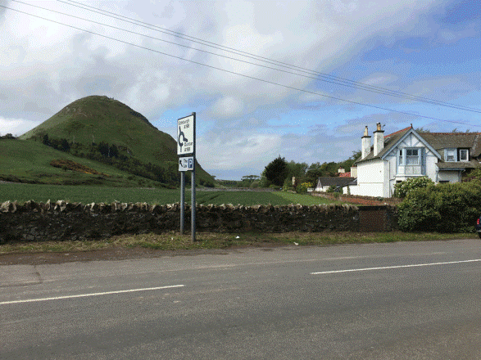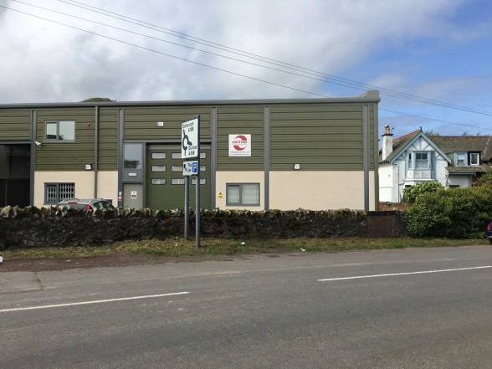

Herons on Heugh Road West proposed site
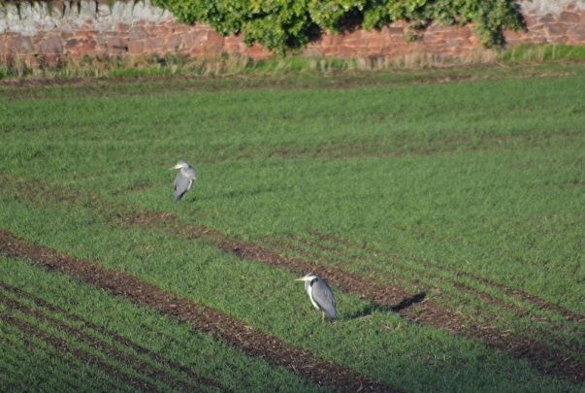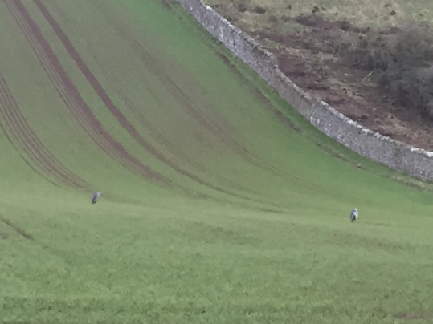

Curlews from and on Heugh Road West proposed site
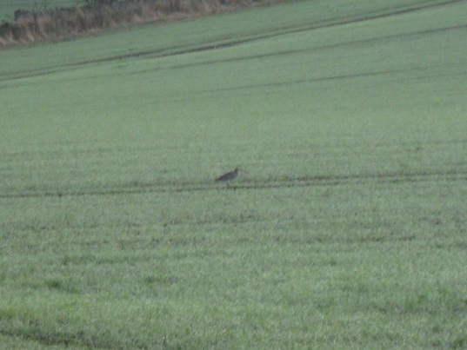

Collapsed wall due to winter rain run off
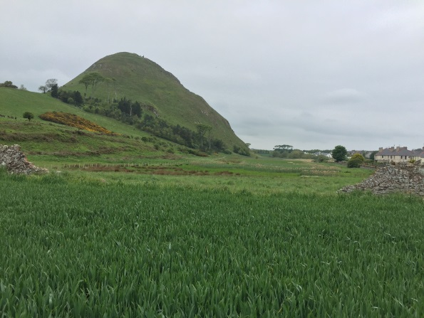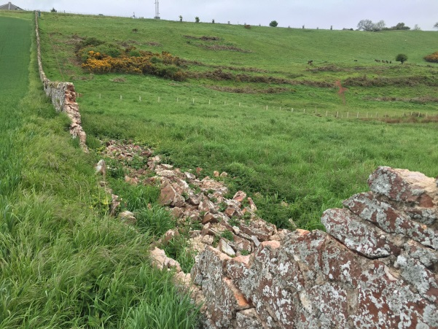

Exmoor ponies regularly graze adjacent to boundary wall (deer also now coming through the gap in the wall onto the field)
