North Berwick
Community Emergency Plan
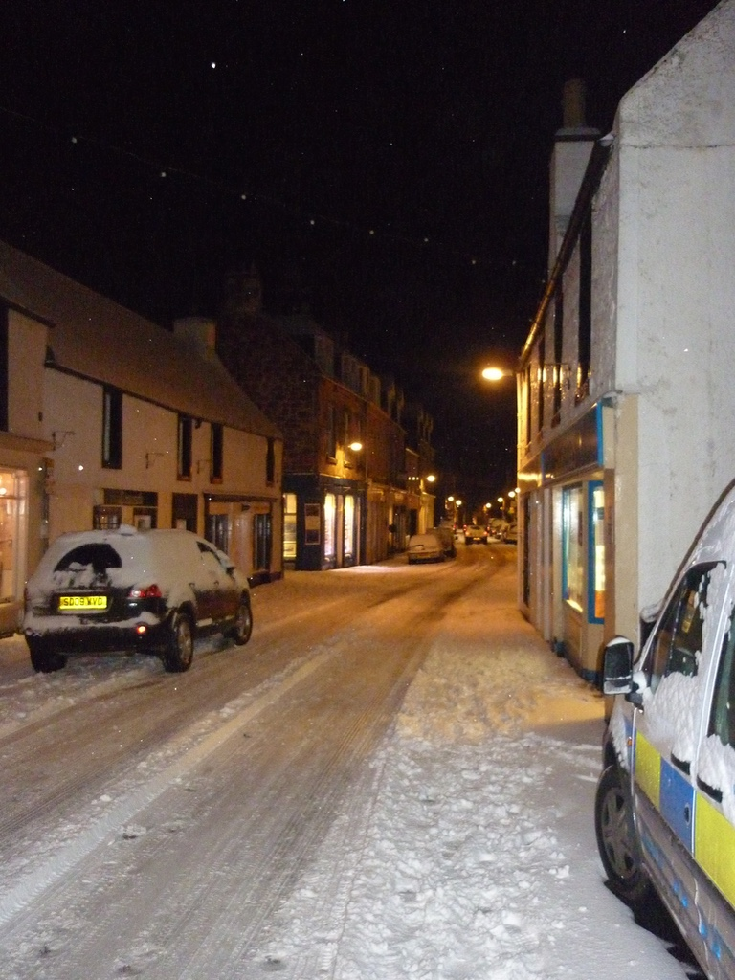

Plan last updated on: May 2015
Final Plan November 2015
Plan to be reviewed May 2017

IF YOU ARE IN
IMMEDIATE DANGER
CALL 999
Amendments to Plan
Name | Details of changes made | Changed by | Date for next revision
Enter Name | Enter Details | Enter Details | Enter Date

Introduction
This Community Emergency Response Plan has been prepared by North Berwick Community Council in consultation with local stakeholders, in line with the provisions of the Civil Contingencies Act 2004 and The Contingency Planning (Scotland) Regulations 2005.
The plan is designed as a community response to an incident that disrupts and has serious consequences for the everyday life of the community. In particular this plan is aimed at assisting those most vulnerable who reside in the burgh or are visiting North Berwick. No attempt is made to define what might cause such disruption, and could be anything from severe weather, flooding or fire to a major power cut. Being aware of the risks that we as a community may encounter and who within the community might be able to assist will make our community better prepared to cope with an emergency.
Local emergency responders will always have to prioritise those in greatest need during an emergency, especially when life is in danger. During these times, we as a community would benefit from knowing how to help ourselves, and those around us until assistance arrives.
Throughout this document, the importance of volunteers to ensuring the wellbeing of the community is clear; however this document is not intended to usurp the statutory obligations of the Scottish Government, East Lothian Council, and the Emergency Services.
This plan, although primarily related to disruptive emergencies and incidents, can also be invoked for other events such as mobilising volunteers to search for missing persons under guidance of Police Scotland. The plan has identified and considered known risks and potential responses. However the plan primarily aims to set up a process of response whereby the community is able to respond and be flexible to any eventuality. The plan will therefore remain flexible to tackle the incident the community face.
The plan is distributed to the following organisations: Community Police, Fire, Coastguard, First Responders, Lifeboat, Local Councillors and Community Councillors, North Berwick Library, North Berwick Community Centre and ELC Emergency Planning Officer. In addition the plan will be distributed to all members of the asset register and individual volunteers.

PURPOSE
In a severe emergency situation, the emergency responders cannot be everywhere at once. They will always have to prioritise people in greatest need, especially where lives are at risk.
Within our community, vulnerable people who may already be using services become more vulnerable in an emergency situation and those that no-one thought of as vulnerable may well become so.
The good news is that how communities organise themselves to prepare for emergencies can make a big difference. The Community Emergency Plan is about how communities can make that difference by coming together to support each other.

Community Resilience

A resilient community is achieved by working together

At the heart of how communities get through emergencies is how ‘resilient’ they are – this means how well we can use our strengths to:
- prepare for,
- respond to; and
- recover from emergencies

More resilient communities:
- are aware of the risks that may affect them and how vulnerable they are to them
- use their existing skills, knowledge and resources to prepare for, and deal with, the consequences of emergencies
- work together to complement the work of the local emergency responders before, during and after an emergency.

This purpose of this Community Emergency Plan is to help our community become more resilient, and cope until the emergency responders arrive; and help us recover in the long term.
Local Risk Assessment

Risks | Impact on community | Actions the Resilient Communities Group can do to prepare and assist?
Inland Flooding | Damage to homes & businesses  Flooding of local streets  Lack of Access & Egress to properties | Encourage residents and businesses to improve home flood defenses  Place sandbags or domestic flood gates into position  Work with local emergency responders to see if they can help with distribution of flood warnings and any evacuation to rest centre establishment required  Identify vulnerable people who live in areas likely to be flooded  Provide response information – local facebook pages e.g NB News and Views and Community Centre Facebook page and local websites
Coastal Flooding | Damage to vessels in North Berwick Harbour  Impact to homes & businesses near to Harbour  Damage to Harbour | Encourage residents and businesses to improve home flood defenses  Place sandbags if available or domestic flood gates into position  Work with local emergency responders to see if they can help with distribution of flood warnings and any evacuation and rest centre establishment required  Identify vulnerable people who live in areas likely to be flooded  Identify owners of vessels so that they can be warned as to possible coastal flooding  Work with other representative organisations who have responsibility for the harbor (NBHTA)  Provide response information when possible such as through the NB Community Council newsletter
Severe Weather  (Snow, Rain etc.) | Road and Footpath inaccessibility  Loss of utilities  Rubbish Collection  School Closure | Caring for the vulnerable people affected  Clearing snow from access routes to homes, community buildings, and schools  Movement of residents to a safe place  Delivery of supplies and fuel to the community  Arranging rubbish collection  Completing critical services for the vulnerable such as collecting medicine and transportation for doctor/hospital appointments  Provide response information when possible such as through Local facebook pages- NB News and Views; NB Buy and sells and Community Centre facebook page
Utility Failure | Loss of gas, electricity and water  Loss of communication | Caring for vulnerable people  Assisting with the delivery of alternative heating sources, water etc.  Making refreshments and food at community buildings  Staffing rest centres until ELC staff arrive  Provide response information when possible such as through local facebook pages such NB News and Views, NB Buy and Sells and the Community Centre Face book page.
Fire | Evacuation  Access to Houses and Businesses  Closure of doors and windows | Assist with alerting the residents.  Assist with the evacuation of residents to a safe place.  Maintaining access routes until the Fire Service or Police arrive
Communication | Loss of communication | Caring for vulnerable people  Alerting residents and establishing contact groups
Rail Crash | Train is derailed entering or leaving North Berwick | Assist the emergency response services as requested  Making refreshments and food at community buildings  Staffing rest centres until ELC staff arrive if one is set up for passengers
Other | Missing persons  Transportation Incident | Identify a meeting point  etc.  Care for affected motorist etc.

It is important to consider what skills, resources and equipment our community already has that could be used, if needed, during an emergency. There is a wealth of knowledge and equipment and other resources in our community. The register below of locations and organisation and individuals who have offered to help in an emergency is the first step in developing a comprehensive local Asset Register. As more people become aware of the plan we expect more individuals and organisations to register. The register will be kept at the North Berwick Community Centre. People can register their offers of support. it also important for local people and organisations to take responsibility to keep their contact details upto date.

LOcal ASSET REGISTER: Key locations, Organisations and Local Skills and Resources

Building/resources /skills | Location | Potential usage in an emergency and skills or resources | Contact details
St Andrew Blackadder Church of Scotland | High Street North Berwick | Safe place and rest centre toilets and refreshments and volunteers | Neil Dougal- neil@neildougall.co.uk  neil@standrewblackadder.org.uk  895233
Abbey Church of Scotland | High Street North Berwick | Safe place and refreshments | David Graham  abbeychurch@btconnect.com  01620892800
Why Not market | High Street North Berwick | Refreshments, food and hot drinks,shelter warmth, toilets | Adam Elder, adam@whynotnorthberwick.com  07932565591
North Berwick Community Centre | North Berwick Community Centre  8 Law Road North Berwick | ELC official Rest centre | Community centre manager – contact details TBC and key pad number for access to centre TBC  nbccinfo@eastlothain.gov.uk  Nicky Fox- nicky.fox@btinternet.com  01620893056
North Berwick Day Centre | 6 St Andrew Street North Berwick | Information and access to vulnerable older people. Transport and Volunteers | Carol Wicker  info@nbdaycentre.com  01620890906
North Berwick Health Centre | St Baldreds Road North Berwick | Access to information about vulnerable people and point of contact GP’s and Nurses | val.thomson@lothian.scot.nhs.uk  mobile number 07974210048  home number 01368850677  as first point of contact for GP and nursing services
NB Youth Project |  | Volunteers and rest centre | Lesley@northberwickyouthproject.org.uk  07773371070
The Abbey, ELC | Old Abbey Road , North Berwick | Residential care Home- Access to vulnerable people and carers | Kayreen Jones-kjones1@eastlothian.gov.uk  01620892014
North Berwick Community First Responders |  | 15-20 First aiders -but can only act as First Responders if called out by the Scottish Ambulance Service. Can deploy skills as first aiders but not as first responders unless deployed by Ambulance Control.. | Isabel Andersen Isabel.anderson.nb@gmail.com  01620894186  07587170529-primary number  Stuart Wight –stuartwight1232btinternet.com
North Berwick Rotary Club |  | Volunteers | Harry Armstrong –harry.armstrong@hotmail.com
North Berwick Rugby Club |  | defib in the clubhouse. We store shovels and access the grit box located in the car park Recreation Park. | Brian Verth  secretary North Berwick Rugby Football Club  email: secretary@northberwickrfc.co.uk  phone: 01620 893510
1st North Berwick Scouts | St Baldreds Road | Volunteers and hall | Sandy Wallace @msn.com
Stepping Out |  | Mental health support and access to vulnerable people | Nicky.fox@btinternet.com
NB Harbour Trust Association |  | Responsible for the harbour area.  Access to support for flooding | gerry_ hughes@btinternet.com  07718315929  hm@harbour.org.uk
NB Rowing Club |  | Volunteers | John Irvine- jeirvine@btinternet.com
North Berwick High School |  | Volunteers
Peppers Paws |  | Care of animals | Natalie Pepper 07581278111
Muddy Mutts |  | Care of animals | Rozelle Small 07581028418
NB library and coastal museum | The old school road | Information hub and communication skills. Kitchen and safe place, toilets | Dionne Howie- assistant in charge 01620820700  Northberwick.library@eastlothian.gov.uk
Individual Members of the Community
Victoria Hogg |  | First aider and four wheel driver | Victoria.hogg17@gmail.com  01620892721  07760265613
Gillian Milne |  | Snow clearing and cooking | Gillian.graham@gmail.com
Lynda Dalgleish |  | Organisational skills and communication | 07747477218
Jackie Tagg |  | Local networks and volunteers | 07779302847  jaxtagg@aol.com

To be able to direct resources, the Community Emergency Co-ordinator needs to know the resources that are available in North Berwick. In order to do this a ‘Community Emergency Asset Register’ will be kept listing people who are willing to volunteer, along with any specialist training or knowledge, and access to tools, equipment and resources (see above). The Community Council will hold the community register. Members of the community are encouraged not only to register, but also to notify any changes, so the list is up to date.

All information provided for the purpose of assisting the community in an emergency situation will be kept confidential, and held in accordance with relevant data protection legislation.

Volunteers
For this plan to work we need the support and enthusiasm from our community. People need to be prepared to sign up and offer to get involved in helping if an emergency happens. Raising awareness and encouraging people to see the value of joining in are an important part of building the plan.

To make our plan most effective, as diverse a group as possible within our community are needed to get involved. Different people bring different skills and opportunities. For example, some people may not be able to clear snow, but could be willing to help look after people who have to leave their homes in an emergency. People from different ethnic communities may have language skills, and could help communicate with people in our community whose first language is not English.
In an emergency situation volunteer groups and individuals will make the difference to ensuring the welfare and well being of vulnerable members of our community, and how quickly we recover from any emergency situation.

In order to make the most effective use of community resources, the Community Emergency Co-ordinator needs access to a list of community volunteers with any relevant skills. Members of the public are encouraged to register as a community emergency volunteer and if they have skills, tools or other resources that could be used. For example, some people may have equipment and expertise they are willing to use while others may be trained in first aid or food preparation. Many people will be able to help in tasks such as clearing snow.
Outside of an emergency, people can register at the North Berwick Community Centre. During an emergency situation, people should visit the North Berwick Community Centre to find out where volunteers are needed and how to get involved.

Tools and Equipment
Within our community there are individuals and companies who use portable generators and other tools or equipment that could be used in the event of an emergency. Those willing to provide assistance in an emergency need to be identified so they can be contacted by the Community Emergency Co-ordinator and directed where they are needed. Again there must be retrospective compensation for the fuel/consumables used.
For example, tree surgeons may have useful skills and equipment and farmers may be willing to use their tractors to help. It is important to make sure that anyone using this kind of equipment is properly qualified and insured to do so. This is for their protection and to protect the people they are helping.

Supplies
In an emergency, our community could require supplies, like fuel, food and water, which may be difficult to obtain. Local businesses and suppliers may be willing to provide them in advance and be reimbursed after the emergency is over. A list of where grit bins are located in North Berwick is attached to this plan.
Vehicles and Transport
In our community there are people who are able to help transport people, supplies or equipment during an emergency. The Community Emergency Co-ordinator will need to know which vehicles the local community could use and know how to access them in an emergency. They need to know if volunteers have access to a car or if a local tradesman is able to take supplies to a community shelter using their van. It is important to make sure that vehicle owners are properly licensed and insured to use their vehicles in this way.

Health & Safety and Insurance
Insurance and liability need not be a barrier to preparing our community for emergencies. Having a Community Emergency Plan does not mean that volunteers will be putting themselves in danger, or endangering other people in the community. In fact it means the opposite.

For every-day activities that you might do to help your neighbours, in a personal capacity, your ordinary household buildings or contents insurance will generally provide personal liability cover. You will need to take reasonable care and should not take unnecessary risks. If you are in doubt, you should check your policy or ask your insurer.

If you are part of an existing group, you will probably have third party liability insurance, and you can check with your insurer that the types of activities you want to do will be covered by your policy.
If a group is not employing anyone health and safety legislation, does not, in general apply.

Voluntary organisations and individual volunteers do, however, have a duty of care to each other and others who may be affected by their activities. In every case it is important to ensure that volunteers working on community resilience activities do so safely and anyone affected by their activities are not put at any additional risk. If your group has control of premises the law requires you to take reasonable measures to ensure the hall, access to it and any equipment and/or substances provided are safe for people using it.

North Berwick Community Council Insurance
All 20 East Lothian Community Councils have public liability insurance paid for by the council.
Phone Pyramid
The phone tree works as a pyramid. The coordinator at the top makes the first call to two or more people. In turn, they call an assigned set of people and so on, until the tree is complete. All telephone numbers will be programmed into the emergency mobile phone number. These organisations will attend the first meeting of the community emergency co-ordinating group. Further calls will be made to the Rotary, Rugby Club, Rowing Club and Scouts depending upon how many volunteers are required and contact details are on the Asset Register

Community Emergency Coordinator- chair of community council

Contact number 01620894666
     
Deborah Ritchie  01620892614  07976176314 |  | HILARY SMITH  07741251434
   |  |   
LOCAL ORGANISATION ON ASSET LIST  First Responders-07587170529  North Berwick Health Centre- 07974210048 and 0136885067 ( Val Thomson)  North Berwick Day Centre-01620890906  Harbour Trust -07718315929  North Berwick Library 01620820700  Abbey Church -01620892800  St Andrew Blackadder- 01620895233  The Abbey Residential Home -01620892014  Youth Project 0777  71070 | REST CENTRE  North Berwick Community Centre 01620893056 | LOCAL VOLUNTEERS  Victoria Hogg 01620892721 and 07760265613  Gillian Milne –gillian.graham@gmail .com  Adam Elder 07932565591  Lynda Dalgleish 07747477218  Rozelle Small (Muddy Mutts) 07581028418  Natalie Pepper (Peppers Paws) 07581278111  Jackie Tagg 07779302847 | COMMUNITY COUNCIL MEMBERS  Jake Scott 07813731466  Elma Danks 01620893115  George Johnstone 07850308515 and 01620481394  Bill MacNair  07718518477 and 01620892205  Peter Hamilton 07535119975 and 01620895356  David Kellock  Ian Watson 07966224150  Kathryn Smith 107702580973 and 016208923

First Steps in a Community Emergency
The police will normally take the co-ordinating role at a major, large or complex incident.
Once an incident moves into the recovery phase, the council will take over the lead role.
The community management of the emergency is the joint responsibility of North Berwick Community Council under the direction of the Community Emergency Co-ordinator.

- The plan will be activated if the risks outlined above are triggered, or if an unforeseen emergency/incident occurs that would benefit from community support.

- The Community Emergency Co-ordinator will alert the community council and the local organisations, local volunteers and the rest centre of the need for a community’s response to an incident. Individuals will take responsibility for telephoning those individuals and organisations indicated on the telephone tree in the first instance. Additional volunteers will be contacted from the asset register depending on need.

- The Community Council will co-ordinate the response from the North Berwick Community Centre and arrange co-ordinating meetings as required until the emergency is controlled. The Community Emergency Coordinator will use a dedicated mobile phone to communicate during the emergency- telephone number …..

- The Community Emergency Coordinator will be the first point of contact with the East Lothian Council Emergency Planning and Risk Manager and the emergency services.

- Volunteers will be asked to congregate at the North Berwick Community centre where tasks will be allocated.

- Organisations who work with vulnerable people will be asked to provide lists of people who are deemed to require additional support during the emergency. All information provided for the purpose of assisting the community in an emergency situation will be kept confidential, and held in accordance with relevant data protection legislation.

- Local Facebook pages will be used to communicate with the wider community and local radio will be asked to transmit any relevant information. In addition requests for help and resources will be made through these channels.

Draft Community Emergency Group first meeting agenda

Example Community Emergency Group Emergency Meeting Agenda
Date: Enter Date
Time: Enter Time
Location: Enter Details
Attendees: Enter Details

1. What is the current situation?
Enter Details

You might want to consider the following:
Location of the emergency. Is it near:
- A school?
- A vulnerable area?
- A main access route?
- Type of emergency:
- Is there a threat to life?
- Has electricity, gas or water been affected?
Are there any vulnerable people involved?
- Elderly
- Families with children
- Non-English-speaking people.
- What resources do we need?
- Food?
- Off-road vehicles?
- Blankets?
- Shelter?

2. Establishing contact with the emergency responders
Enter Details

3. How can we support the emergency responders?
Enter Details

4. What actions can safely be taken?
Enter Details

5. Who is going to take the lead for the agreed actions?
Enter Details

6. Any other issues?
Enter Details
Actions agreed with local authority in the event of an evacuation
The North Berwick Community Centre is the official rest centre if people need to be evacuated.
East Lothian Council (ELC) are responsible for opening and staffing this rest centre. ELC has a Rest Centre plan and staff exercise this plan on a regular basis.
However, should an incident stretch the ELC resources assistance from North Berwick Community Council volunteers will be requested.

Household Emergency Plans

If a major emergency happens it may be some time before help arrives. It’s very important that you and your family get together to prepare.

Agree a plan in advance with those in your home
Complete this template together and keep it safe in case you need to use it.

If the emergency means it is not safe to go out, the advice is usually to:

GO IN (go indoors and close all windows and doors)
STAY IN (stay indoors)
TUNE IN (to local radio, TV or the internet, where public information and advice from the emergency responders will be broadcast)

Local Facebook Pages North Berwick News and Views and local radio will be used to communicate with you.

If you have to leave your home, get out, stay out, and take others with you.

Think of two meeting places: one near home and one further away, in case you can’t get home.

Meeting Place 1 (Near Home) Meeting place 2 (Further away)

Location………………………… Location …………………………….
……………………………………. …………………………………………
……………………………………. …………………………………………

Pick a friend or a relative who lives out of the area, who you will agree to call to say you’re OK, should you need to leave home. Make sure this person knows.

Friend or relative to call to let people know that you’re OK

Name:…………………………………

Telephone number:……………………….

If it is safe to do so, you should check on your neighbours and vulnerable people living close by. Have a think about who they are in advance.

Name:…………………………  Address:……………………  …………………………………  …………………………………  Tel Number:………………… | Name:…………………………  Address:……………………….  …………………………………..  …………………………………  Tel Number:…………………… | Name:……………………………  Address:………………………..  ……………………………………  ……………………………………  Tel Number:……………………

Additional Information
Additional information to assist with this plan:
- Contact the East Lothian Council, Emergency Planning and Risk Manager on 01620827779 or 07768916176
- Scottish Government Ready Scotland –My Community web page-http://www.readyscotland.org/my-community
- East Lothian Council webpage for Emergency Planning (includes copies of severe weather and Torness Off Site Emergency response plan) http://www.eastlothian.gov.uk/info/1226/emergencies/334/emergency_planning
- Emergency contact numbers http://www.eastlothian.gov.uk/info/1226/emergencies_and_emergency_services/1399/emergencies_contact_details
- Scottish Power http://www.spenergynetworks.co.uk
- Scottish Environment Protection Agency (SEPA) : http://www.sepa.org.uk/environment/water/flooding/responsibilities-for-flooding/

